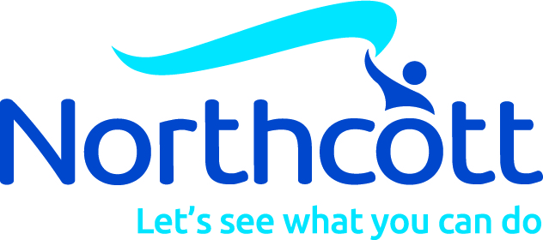
School Request For Support Form
Specialist Disability Support in Schools (SDSS) Program
z
Specialist Disability Support in Schools (SDSS) Program

School Support Services
SECTION A
(If this request is for more than one eligible student, only one Section A is required)

Service Request
School Name:
School Address:
School Email Address:
School Phone Number:
Name of person making request:
Position of person making request (Contact):
School Contact’s Phone Number:
School Contact’s Email Address:

Has the school contacted their Regional Office to check if there are any supports and/or school based therapies available from the education sector? |  | ☐ | Yes | ☐ | No

February 2024

Please return to: northcott@northcott.com.au

Call: 1800 818 286

SECTION B
(If this School Request for Support Form is for multiple eligible students, a Section B must be completed for each eligible student)

Student Details
Name:
School Year Level:
Impairment Categories:

SDSS Services – Student Eligibility

Check the relevant box/es regarding student eligibility:

☐  ☐ | - Students who were recorded in the latest submission of the Nationally Consistent Collection of Data on School Students with Disability (NCCD) as receiving supplementary, substantial or extensive adjustments; or  - the school requires assistance to address a barrier to the student’s physical access to the school environment; or
☐ | Students new to a school (including Prep students)  - School has evidence of a diagnosed disability and has confirmed by the end of Term 1 that the adjustments provided are consistent with the descriptors for either supplementary, substantial or extensive in the NCCD Guidelines (please refer to the NCCD Selecting the level of adjustment matrix):  - Supplementary: Student receives adjustments supplementary to the strategies and resources already available for all students within the school for particular activities at specific times throughout the week.  - Substantial: Student has substantial support needs and receive essential adjustments and require considerable assistance to the usual educational program at most times, on most days.  - Extensive: Student has very high support needs and are provided with extensive targeted measures and sustained levels of intensive support at all times.

- Does the student access specialist education services at the school?
☐ | - Special Education Support | ☐ | AVT
☐ | - Therapy Services | ☐ | Teacher Aide Support
☐ | - Other (Please provide further details):
- Please describe key concerns regarding the student’s access to and participation in the curriculum:

School Consent
Principals (or delegate), your consent is required by ticking the box beside the statements below. SDSS services cannot be provided until all statements are agreed to:

☐ | I understand that Northcott will provide services at our school and will work in collaboration with the student’s educational team to provide advice and support for the development and implementation of the student’s Personalised Learning Plan.
☐ | The relevant school policies and procedures, including child safety and mandatory reporting requirements, have been viewed and completed by Northcott.
☐ | Consent has been received from a parent/guardian for each student listed in Section B of this request to receive a SDSS service from Northcott at our school.
☐ | I confirm that each student listed in Section B of this request meets the eligibility requirements to receive a SDSS service, as listed in the previous section, SDSS Services – Student Eligibility.
*Privacy Collection Notice: All approved SDSS organisations have a current service agreement with the Department of Education, which requires them to adhere to strict Disclosure of Confidential Information and Protection of Personal Information clauses when delivering a service.
The personal information gathered by Northcott for this request is for the purpose of delivering services to improve access to and participation in curriculum and educational outcomes, and will not be used for any other purpose or given to any other party unless you have consented or we are authorised by law to do so.

Principal’s (or delegate’s) signature:
Print Name:
Date:

Main area of concern
 | Autism Spectrum Disorder |  | Hearing Impairment
 | Intellectual Disability |  | Physical Impairment
 | Speech and Language issues |  | Vision Impairment
 | Social Emotional concerns

Are there any behaviours of concern?
Yes
No
If yes, please give details below

Service Type
☐ | School Support Services | ☐ | Resource Centre Services
☐ | Specialised Equipment

How can Northcott help? Please nominate support requests below (tick all that apply)
 | Speech Pathology |  | Occupational therapy
☐ | Speech and language development | ☐ | Review of toileting area & assistance with equipment e.g. hoists
☐ | Alternative communication e.g. symbols, PODD books, iPad | ☐ | Trial of supportive seating/equipment for writing tasks
☐ | Literacy skill development | ☐ | Trial of technology e.g. software, alternate mouse/keyboard
☐ | Computer software to assist with literacy | ☐ | Trial of pencils and pencil grips
☐ | Mealtime safety | ☐ | Sensory screening and recommendations
 | Physiotherapy |  | Team
☐ | Playground and general school access | ☐ | Support with planning for camps/excursions
☐ | Safe use of PDWC or scooter in the school environment | ☐ | Staff training around the child's condition/needs
☐ | Improve balance and coordination | ☐ | Staff manual handling training
☐ | Modifications for HPE programs
☐ | Other
(Please list any other services required below OR add further details about the request)

